DB special report (US fixed income weekly, 2020-4-17)

1. potential for the fed's purchases of coupon securities in 2020 to top 3 trillion, about 220% of net issuing including T-bills.

2. Fed daily purchases 20bn-15bn-10bn

3. Fed has every reason to maintain financial conditions eased. Reasonable to set up front-end yield curve control

4. YCC control in the front end likely to paired with longer term QE, as more relevant

5. Expect fed to buy 100 bn per month in coupon Treasuries in H2, focusing on 7-30 year maturity sector.

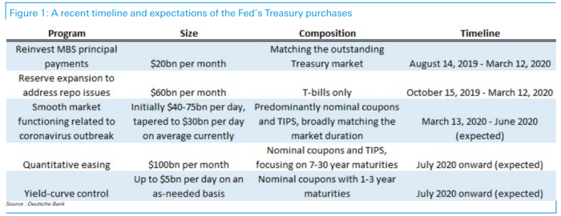

6. Treasury liquidity has recovered 80-85% in notes and about 65% in bonds relative to their pre-pandemic levels.

notes: 2-10 years

bills: less than a year

bonds: 10 to 30 years

7. 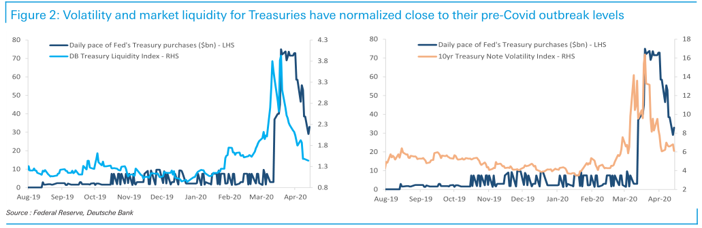

8. 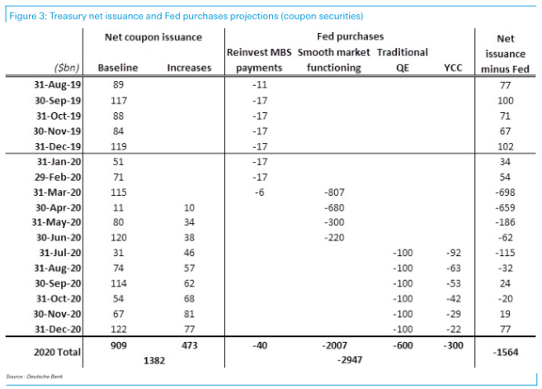

9. 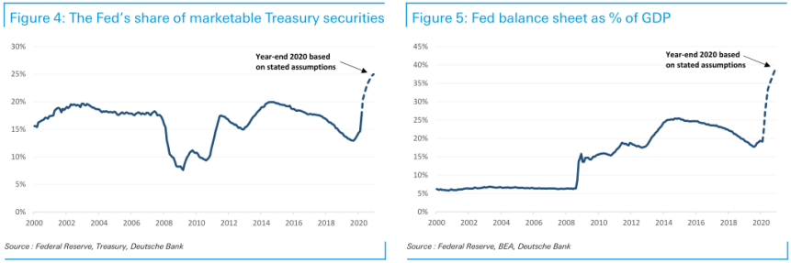

10. In 2008: policy transmitted through rates: crowding out UST and supplying convexity to the rest of the market, fed made credit as an attractive alternative through higher yield and positive carry.